

Rockbuster

Data Dictionary



April 16, 2025

Rockbuster

Contents

Dictionary 2

Fact tables 2

Dimension tables 2

# Dictionary

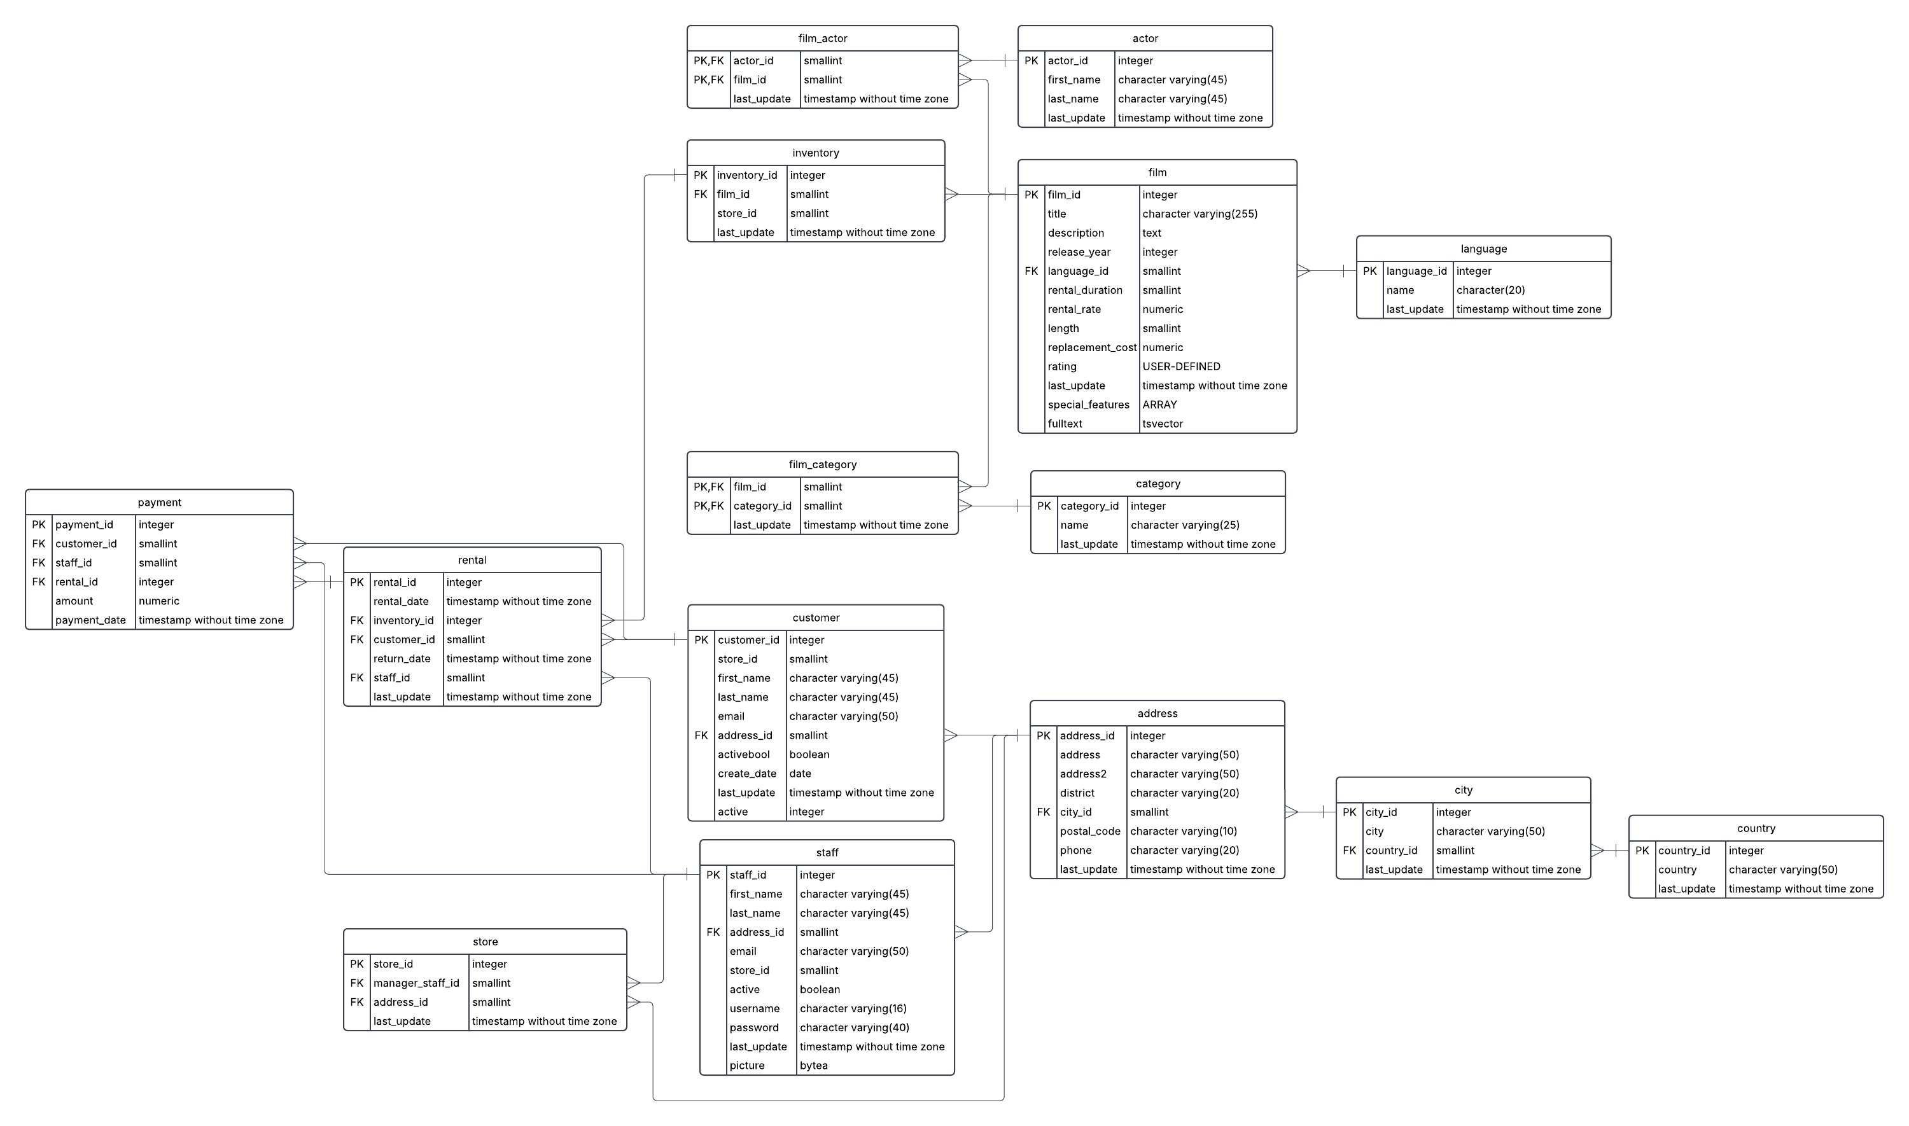

It is a snowflake schema because it has sub table from sub table.

# Fact tables

|  |  |  |
| --- | --- | --- |
| Name | Data type | Description |
| rental | Integer, timestamp without time zone, smallint | Information about each rental |
| Store | Integer, smallint, timestamp without time zone | Information about each stores |
| film | Integer, character varying (255), text, smallint, numeric, USER-DEFINED, timestamp without timezone, ARRAY, tsvector | Information about each film, including detail about the film as well as detail about rental condition |

# Dimension tables

|  |  |  |
| --- | --- | --- |
| Name | Data type | Description |
| Film_actor | Smallint, timestamp without time zone | information about actors in each films |
| Actor | Integer, character (45), timestamp without timezone | Information about the actors |
| Film-category | Smallint, timestamp without time zone | Information about which film belong to which category |
| Category | Integer, character (25), timestamp without time zone | Information about all the category |
| Customer | Integer, smallint, character varying (45, 50), Boolean, date, timestamp without time zone | Detail information about customers |
| Store | Integer, smallint, timestamp without time zone | Information about each store renting out the films |
| payment | Integer, smallint, numeric, timestamp without time zone | Information about each payment of each rental |
| Inventory | Integer, smallint, timestamp without time zone | Information about where or which film are available |
| Language | Integer, character (20), timestamp without time zone | Information about the language of the films |
| Staff | Integer, character (16, 40, 45, 50), smallint, boolean, timestamp without time zone, bytea | Information about staff of each stores |
| Address | Integer, character (10, 20, 50), smallint, timestamp without time zone | Addresses of staff, customers, stores |
| City | Integer, character (50), smallint, timestamp without time zone | Detail cities of each countries |
| County | Integer, character (50), timestamp without timezone | Detail county of each cities |

# Link Tables

|  |  |  |  |
| --- | --- | --- | --- |
| **Table** | **Unique Key(s)** | **Links To** | **Links From** |
| payment | payment_id | customer, rental, staff | None |
| rental | rental_id | inventory, customer, staff | payment |
| inventory | inventory_id | film, store | rental |
| film | film_id | language, original_language | inventory, film_category, film_actor |
| film_category | (film_id, category_id) | film, category | None |
| film_actor | (film_id, actor_id) | film, actor | None |
| customer | customer_id | address, store | rental, payment |
| store | store_id | staff (manager), address | customer, inventory |
| staff | staff_id | address, store | rental, payment, store (manager) |
| address | address_id | city | customer, staff, store |
| city | city_id | country | address |
| country | country_id | None | city |